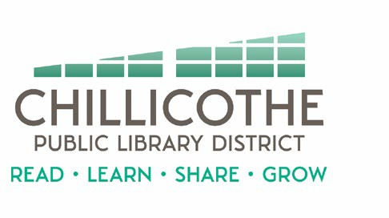
Chillicothe Public Library
Regular Board of Trustees Meeting
April 23, 2024 @ 5:30 pm

AGENDA

- Call to Order
- Public Comments
- Trustee Oath of Office
  - Sharon Hollandsworth
  - Stacey Long
- Approval of Minutes
- Approval of Bills
- Treasurer's Report
- Director's Report
- Unfinished Business
- New Business
a. Programming Policy – action
b. Public Meeting Room Policy – action
c. Director’s Annual Review - discussion during this portion of the meeting may be held in closed session pursuant to 5 ILCS 120/2(c)(1)
- Announcements
- Adjournment

