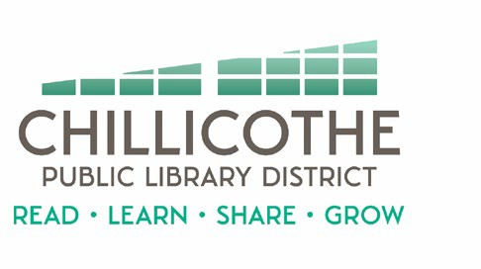
Chillicothe Public Library
Regular Board of Trustees Meeting
March 25, 2024 @ 5:30 pm

AGENDA

- Call to Order
- Public Comments
- Trustee Candidate Introductions
- Approval of Minutes
- Approval of Bills
- Treasurer's Report
- Director's Report
- Unfinished Business
- New Business
  - IGA - discussion
  - Programming Policy – Draft
  - Public Meeting Room Policy - Draft
- Announcements
- Adjournment

